Freshwater Ecology
BIOSCI 1170 (Pitt), PLE 4473 (PennWest)
Session 3, 2024; Pymatuning Laboratory of Ecology
June 24 – July 12

Instructor: Andy Turner, Clarion University
aturner@clarion.edu
814-538-9646 (cell)

About the Course

Freshwater ecology is a holistic study of lakes, streams, ponds, marshes, and swamps. Because freshwater ecosystems provide society with a number of crucial services, aquatic ecology has emerged as an important discipline of environmental science. In order to understand how human activity will affect our drinking water, our recreation, and other values associated with lakes and streams, we must first understand how aquatic ecosystems work.

In this field course, taught at the Pymatuning Laboratory of Ecology in northwest Pennsylvania, students will explore the structure and function of streams, lakes, and marshes. Students will attend background lectures, conduct experiments and field surveys, participate in data collection and analysis, and gain experience in the interpretation and presentation of results. Hopefully students will leave the course with a greater knowledge of and appreciation for Pennsylvania’s rich aquatic resources. In this class we will cover the physical, chemical, and biological functioning of aquatic ecosystems. We will learn how to integrate mathematics, physics, chemistry, and biology in our study of aquatic ecosystems. In addition, we seek to expose students to current research in aquatic ecology, and we will emphasize how scientific knowledge is integrated with social values in addressing environmental concerns.

Topics Covered in this course will include:
- The physics of water
- Chemical limnology
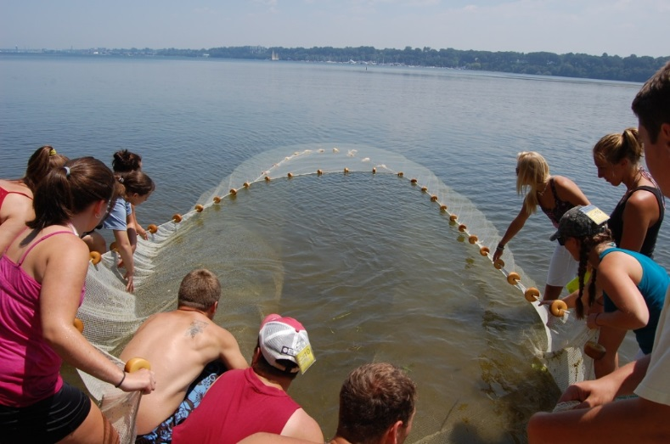
- Quantitative methods for assessing water quality and sampling aquatic communities
- Physiological and behavioral ecology of aquatic organisms
- Trophic interactions
- Stream ecology
- Ecology of fishes
- Water management issues
- Current research in aquatic ecology
- Current water quality concerns in Pennsylvania
- Professional opportunities in freshwater ecology
Schedule 2024

Mon. 6/24 Introduction to PLE, lab site tour. Course Introduction.
Begin Part I: Ecology of Lakes and Ponds.
Lecture: Introduction to the Actors: Plant and Invertebrate Diversity, Benthic Invertebrates in Food Webs
Lab: Plant and Invertebrate Survey, Linesville Creek, Geneva Ponds.

Tues. 6/25 Chemical and Physical Properties of Water, Light and Heat in Lakes, Thermo-Density Relationships and Lake Stratification, Hydrology and Climate, Lake Formation, Lake Morphometry
Lab: Vertical Profiles, Temp., O₂, pH, Cond., Light, Alkalinity
Split class, Conneaut Lake and Pymatuning Reservoir

Wed. 6/26 Salinity, pH, Dissolved Oxygen, ORP, Carbon cycling
Lab: Longitudinal study of Pymatuning Reservoir

Thurs 6/27 Phosphorus cycling, Nitrogen cycling, Primary Productivity
Lab: Pymatuning Reservoir, effects of lotus on limnological processes

Fri. 6/28 Glacial Lakes of Pennsylvania
Lab: Kettle Lake Tour: Edinboro, LaBouff, Lake Pleasant

Mon. 7/1 Food webs in lakes
Lab: Fish Diet Study, Pymatuning

Tues. 7/2 Test 1: 8:30 AM
Purturbation and Recovery of an Aquatic Ecosystem: Case Study of Lake Erie
Lab: Presque Isle Field Trip

Wed. 7/3 Part II: Stream Ecology
Physical and chemical properties of streams, Linesville Creek, Conneaut Creek.

Thur. 7/4 No Class

Fri. 7/5 Aquatic Insect Assemblages in Streams, using an IBI to assess water quality
Field Trip: Shenango River

Mon. 7/8 Food Web Interactions in Stream Ecosystems
Lab: Electrofishing Linesville Creek, Shenango River

Tues. 7/9 Allegheny River Field Trip
Trout streams of the Allegheny Plateau
Tionesta Hatchery

Wed. 7/10 Threats to Pennsylvania’s surface waters
Field Trip: French Creek

Thur. 7/11 Acid-Mine Drainage, Acid Rain
Lab: Tour of Linesville Fish Hatchery, Meet PAFBC Biologists
Lab: French Creek Canoe trip

Fri. 7/12 Test II: 9:00 AM
Presentation of Research Projects: 1:00 PM

About the Course

Daily Schedule: We will begin lecture each day in the fish lab at 8:30 AM sharp, and we will generally conclude the day’s activities by 5:00 PM. The van will leave the dining hall for the lab site at 8:15 AM. Please be on time. We may deviate from this schedule from time to time.

How to Dress: This is a course in aquatic ecology, and we will spend most of this course in the water, and sometimes in murky, muddy water. You will want to wear waders when you are electrofishing or working in very muddy ponds. You may borrow hip boots from PLE, or you may elect to purchase your own. It is generally most comfortable to wear shorts and wading shoes when performing field activities other than electroshocking or in muddy ponds.

Safety: Nothing in more important than your personal safety. If you are uncomfortable with the water, wear a life jacket. Use caution and common sense when using the boats, electrofishing gear, etc.

Grades: You are responsible for all material covered in lecture, laboratories, and the field. In particular, you should know the names of the fish, amphibians, invertebrates, and aquatic plants we encounter. You may find that a field notebook is a useful tool. Final scores are calculated as follows:
Test I: 30%
Test II: 30%
Quizzes (3) 20%
Project 10%
Performance on other individual and group activities: 10%
Grades will be assigned as 90-100 = A, 80-89 = B, etc.

Attendance: I expect that each student will attend and participate fully in all 14 class meetings. Each day of unexcused absence from class will result in a 10% penalty to your final score. Any missed quizzes or tests can not be made up.

